Ecology

What is Ecology? Gr. “oikos” means house & “ology” means the study of

- The study of the “household” of nature.
- __________________________________________________________________________________________ __________________________________________________________________________________________

Ecosystem Structure
- Biotic Factors
  - ____________________________________________________________________________________
    - Examples: bacteria, archaea, protists, fungi, plants, animals, feces, oil, fossils, coal
- Abiotic Factors
  - ____________________________________________________________________________________
    - Examples: rocks, soil, water, light, air, temp

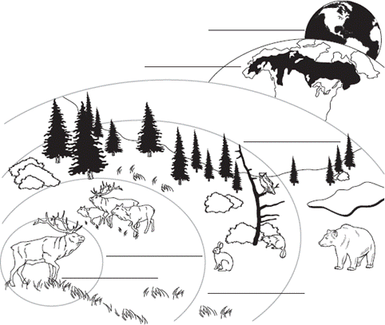

Levels of Organization

Individual
Population
Community
Ecosystem
Biome
Biosphere

What is an Individual?
An individual is ____________________

What is a Population?
A population is ____________________________________________________________________________________

What is a Community?
A community is ____________________________________________________________________________________

What is an Ecosystem?
An ______________________________________________________________________________________________ _________________________________________________________________________________________________

What is a Biome?
A biome is a ______________________________________________________________________________________ _______________________________________________________________________, e.g. savanna, desert, rainforest

Map of Earth’s Major Biomes
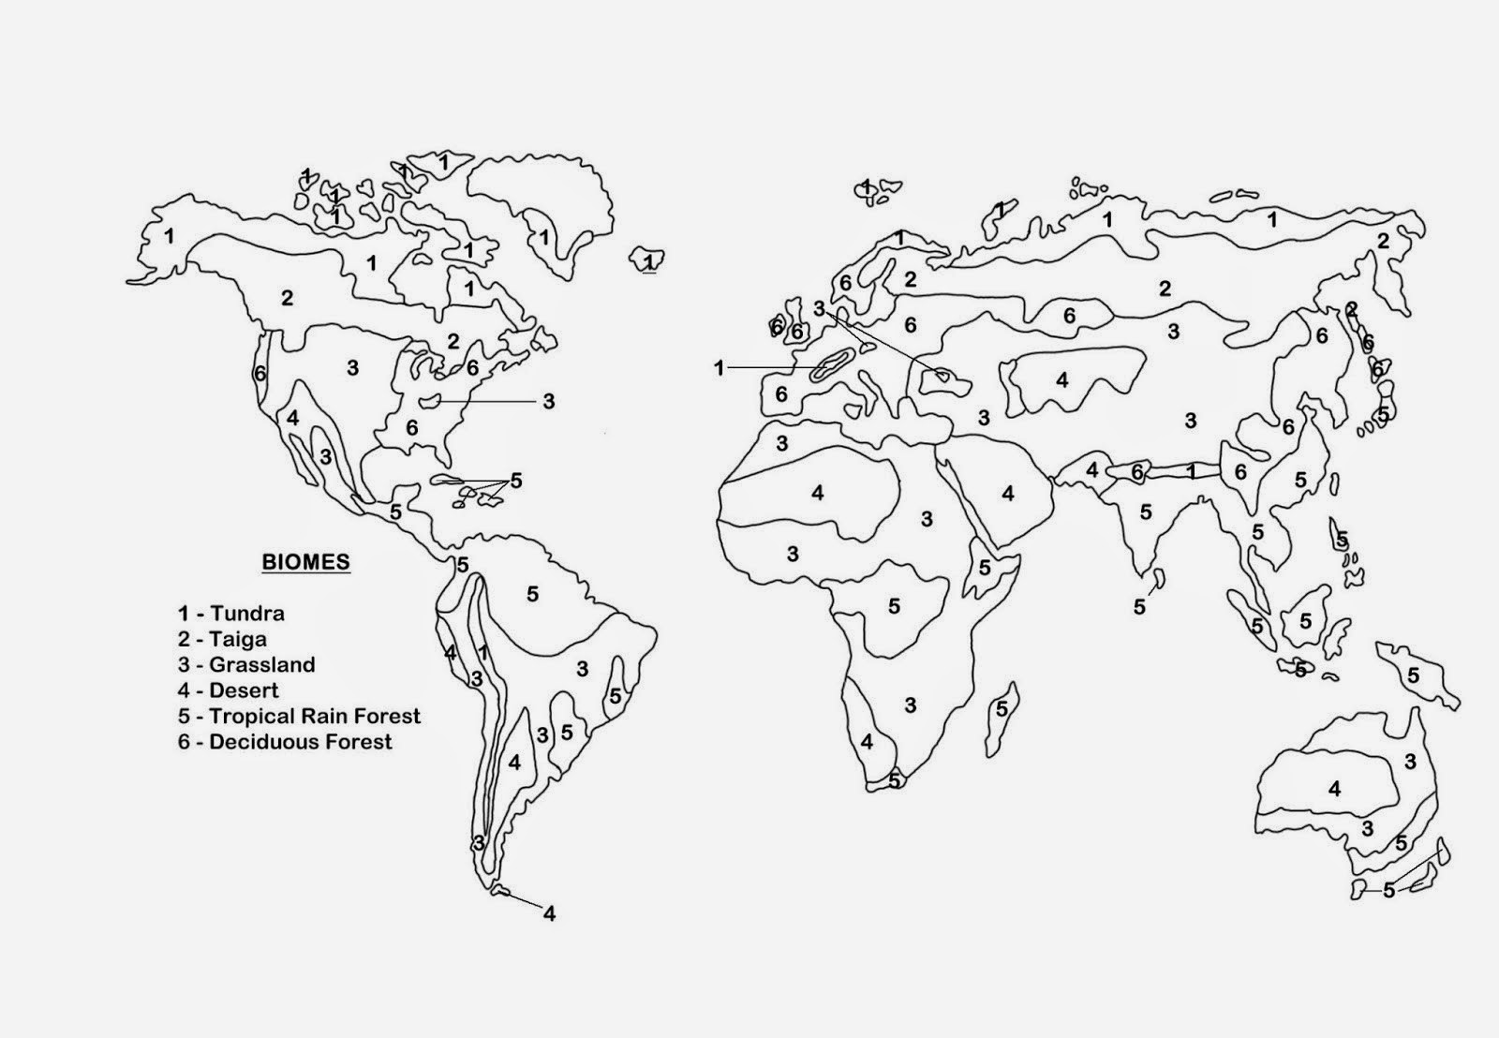

Interspecies Interactions
- Interactions between _____________________________________________________________________
  - Competition (-) (-) _________________________________________________________________
  - Predation (+) (-) __________________________________________________________________
    - Traditional Predation
    - Herbivory
    - ____________________
- Mutualism (+) (+) ______________________________________________________________________
- Commensalism (+) (0) __________________________________________________________________

Competition
- Often ___________________________________________, e.g. food, mates, etc.

Predation
- The act of ___________________________________________________________________________

Parasitism
- ______________________________________________________________________________. One organism feeds on another organism, ________________________________________________________.

Symbiosis (“sym” together “bio” life “sis” the state of)
- A relationship in which ______________________________________________________________________
- Mutualism
  - __________________________________________________________________________________
- Commensalism
  - __________________________________________________________________________________

